控制器下载软件使用说明书
- 控制器软件安装
Double click “MSCOMM” to install Software for customer according to default setting.
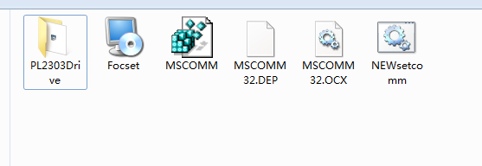
- Connect the USB
Connect the controller and computer with USB cable.
Press the BOOST button, and turn on the power. And then release the BOOST button to enter the firmware updating stage of the controller.
- Firmware Update
Open the software download from our company’s website。Here are the operation steps
  - Choose “communication port setting”(In Windows OS，check the hardware of your computer to get the number of COM）.
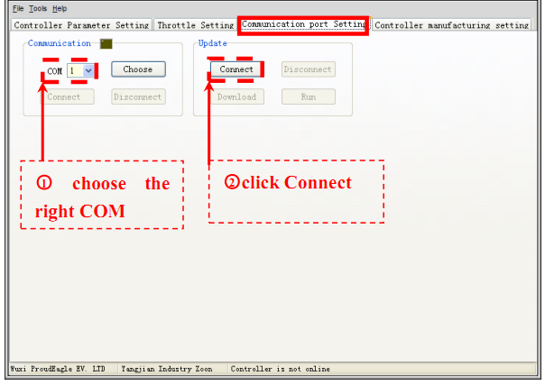
  - Click “Download” and open the firmware document located in your computer, then the download will start automatically. Click “OK” after the process of updating is finished. Please refer to the following picture.

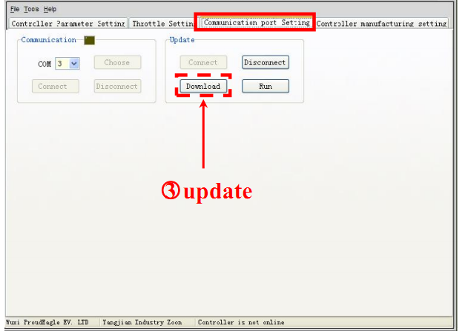
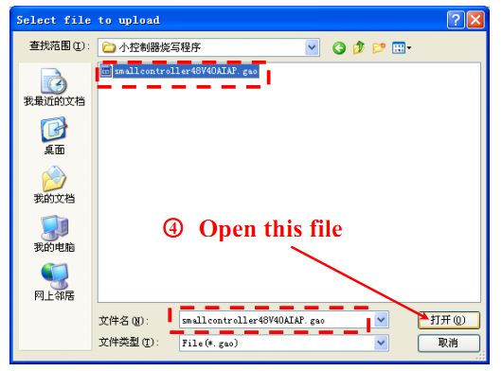
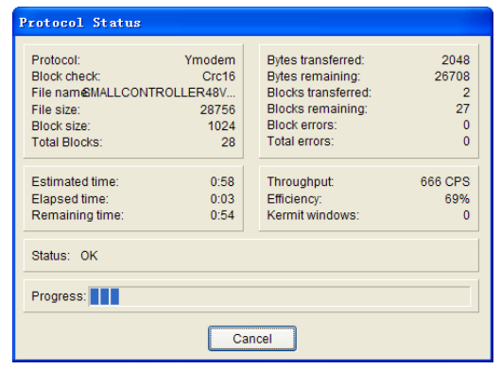
3. After finishing updating, click “Disconnect” button to exit the download mode。
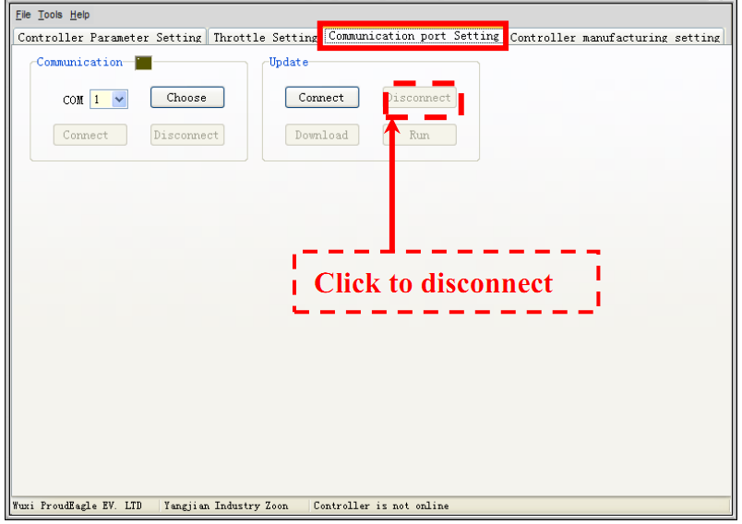
Usually, this stage is done by manufacturer in mass production according the customers’ request. Only when there is a new version of firmware which is given by Our Technical Department, then customers can follow the above instruction for updating.
4. Parameters Setting
Continue the parameters setting under the Focset GUI. choose “communication port setting”。Reconnect the controller by following A,B and C steps. And confirm the controller is online.
1. Connect COM
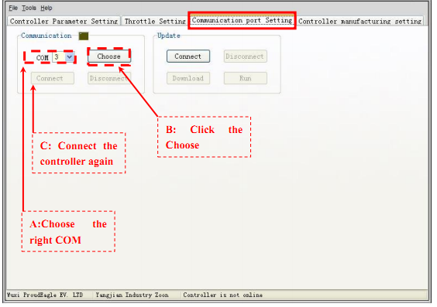
2. After connecting successfully, set each of these parameters according to customer’s requests. The instructions are shown below.
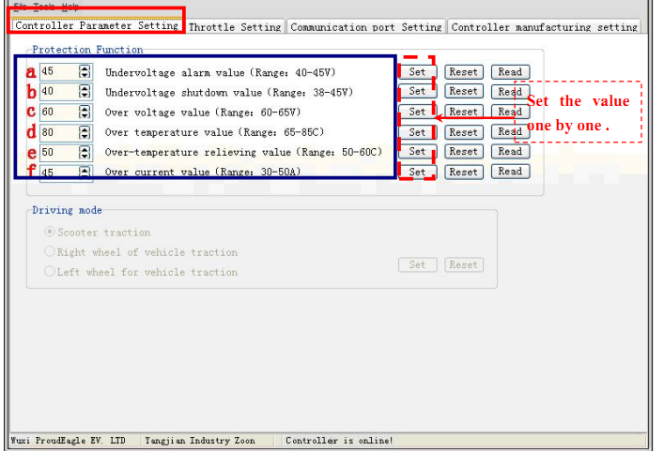
a: Under voltage alarm value
Not used.
b: Under voltage shut down value
When the voltage is lower than the setting value, controller will be power-off。
c: Over voltage value
when the voltage is higher than the setting value, controller will be shut off to stop the motor。
d: Over temperature value
when the temperature of heat sink is higher than the setting value, controller will limit the motor current and speed.
e: Over temperature relieving value
When the temperature of heat sink is lower than the setting value, controller will stop over-temperature protect and the controller starts to work again.
f: Over current value
Not used.
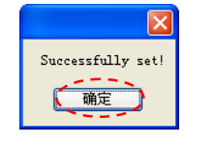
3. Throttle setting click“Throttle Setting”
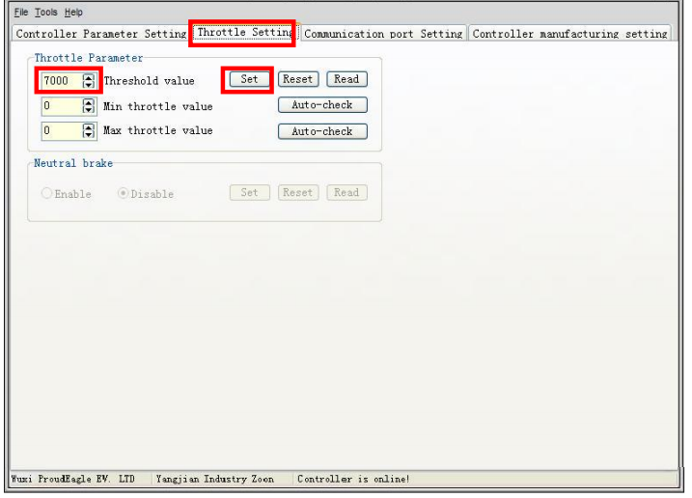
Set the Threshold value as default.
4. Controller Manufacture setting
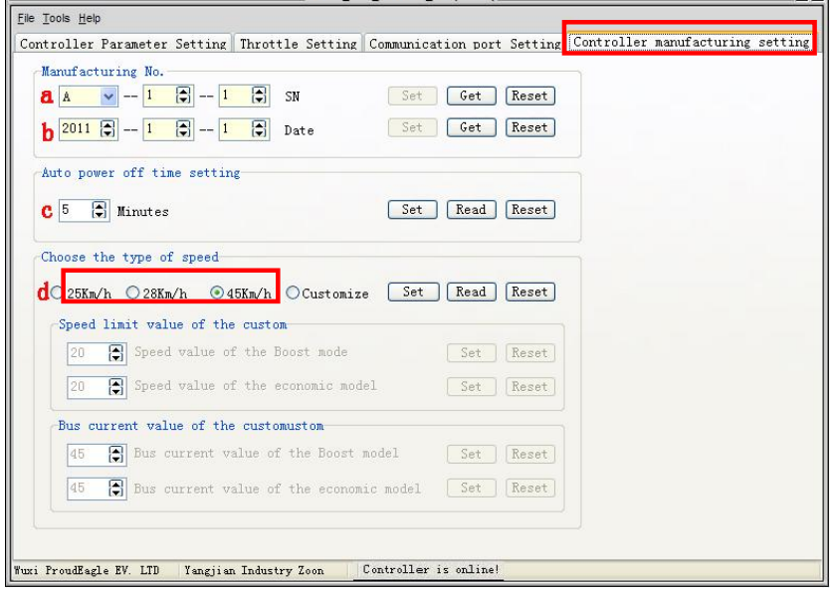
a: SN number: “A” indicates hardware version, following by firmware version and customer code.
b: Manufacture date: the date when the controller assembled
Note: customer can only read the above two parameters.
c: Auto power off time setting. The power automatically shuts down when the idle time exceeds the setting value。
d: Customize setting. Pleases refer to customize setting.
e: Click“customize” button and enter customize setting。
Max Speed value：the value set here is not the real speed shown on speedometer. Customer can modify this value according to the real speed.
Max Current limit：customer can set the max current value for economic mode and BOOST mode .
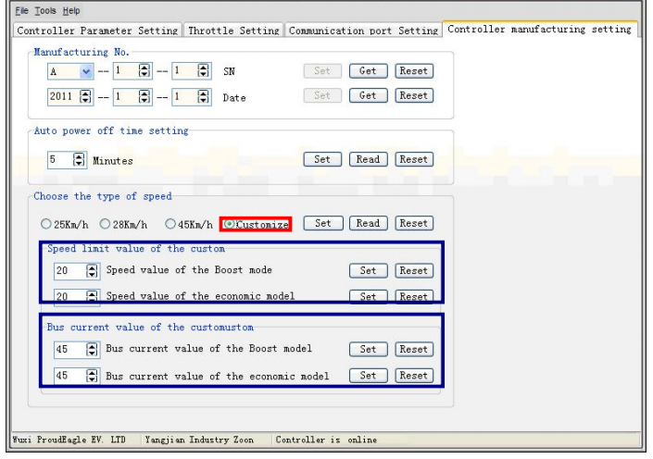
- Finish the parameter setting
After finishing all above settings, enter“communication port setting”，and click“Disconnect” to finish the parameters setting。
